Configuration of Permanent
Magnet Electric Motor
 |  | 5KW Brushless DC Motor
NO. |  | Parmeters |  | Units | Amount | Remark
1 |  | Rated Power |  | kW | 5
2 |  | Peak Power |  | kW | 10 | Limiting the specific values of the secision by the controller
3 |  | Rated Voltage |  | V_{DC} | 72
4 |  | Rated Current |  | A | 80
5 |  | Rated Torque |  | Nm | 17
6 |  | Overload Torque |  | Nm | 50 | Limiting the specific values of the secision by the controller
7 |  | Rated Speed |  | rpm | 2800
8 |  | Max. Speed |  | rpm | 3400
9 |  | Anti-Electromotive |  | V/rad·s⁻¹ | 0.17
10 |  | Phase Current Average |  | A | 106
11 |  | Working Type |  |  | 1h
12 |  | Protection Grade |  |  | IP55
13 |  | Insulation Level |  |  | F
14 |  | Cooling Mode |  |  | AIR
15 |  | Frame |  |  | Y112-B35
16 |  | Weight |  | kg | 25
17 |  | Appearance
 |  | 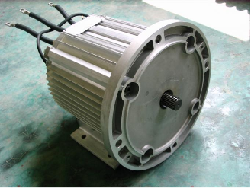 |  |  |  | Practical requirements of motor output shaft can be customized
18 |  | Size | mm |  | Φ184×L297MM
CONTROLLER SPECS. |  |  | BSC15-72
INPUT VOLTAGE RANGE 18-88V COOLONG TYPE AIR
MAX OUTPUT CURRENT 300A WORKING TEMPERATURE -20-60
 | 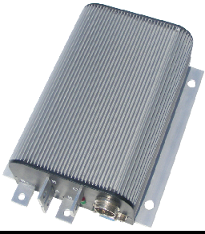 |  |  |  |  | SIZE 200X146X62MM
KEEP TEMPERATURE -30-80 WEIGHT 2.5 KG

PEDAL
INPUT VOLTAGE | 0.8--4.2V
CONTROL TYPE | POTENTIONMETER
INPUT VBOLTAGE | 5v
Resister | 10k
